Level 10 -> Level 11

The goal of this level is to find the pass to log into <http://natas11.natas.labs.overthewire.org>.

Username: natas11

After logging into level 10 we got a hint to get the password of next level. Again, **there is a link to view the source code.** So, simply click on the link to view page source.

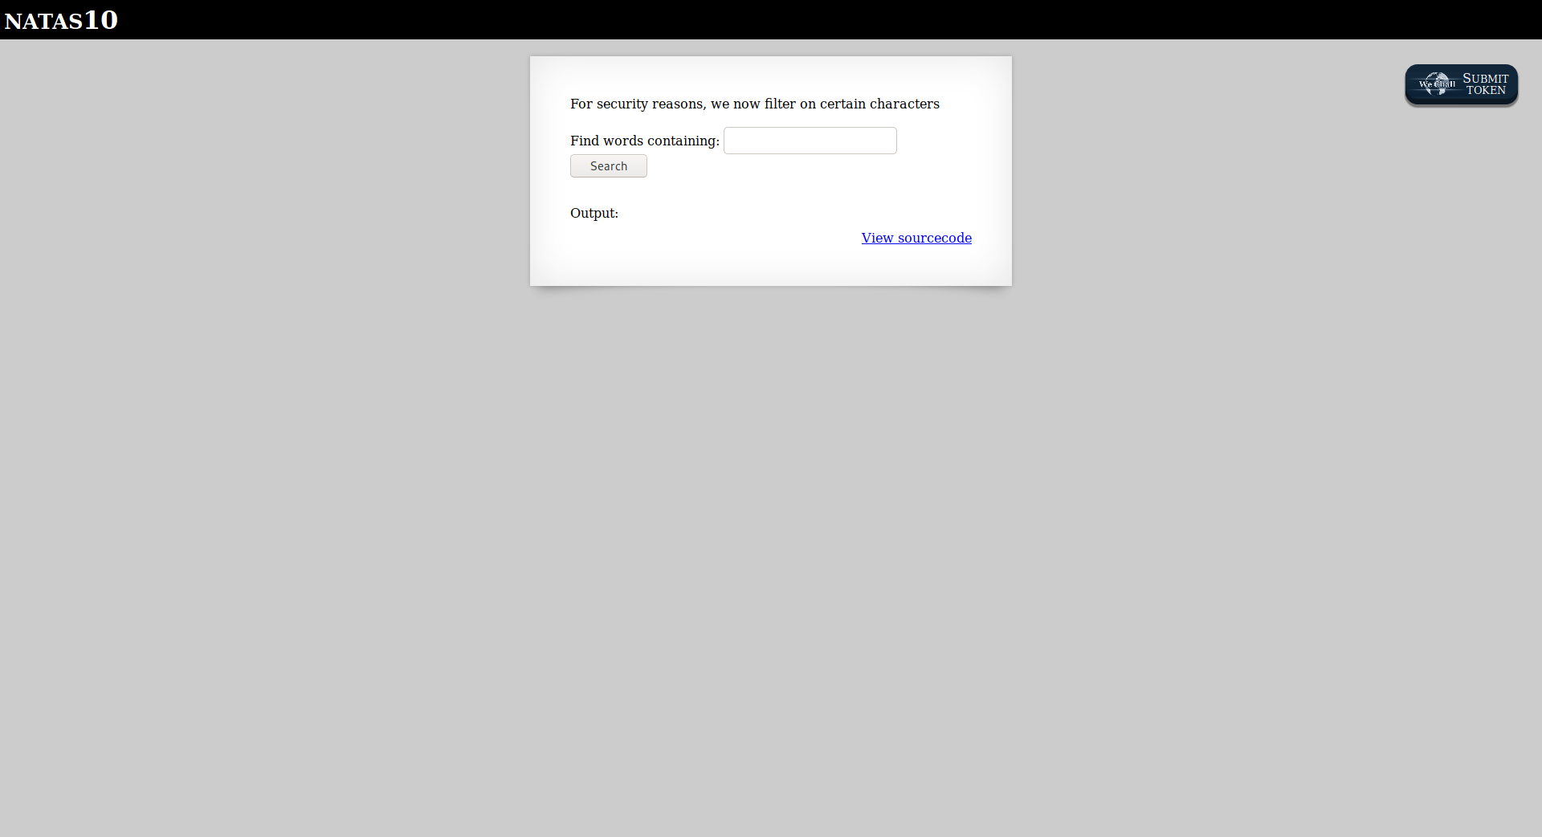

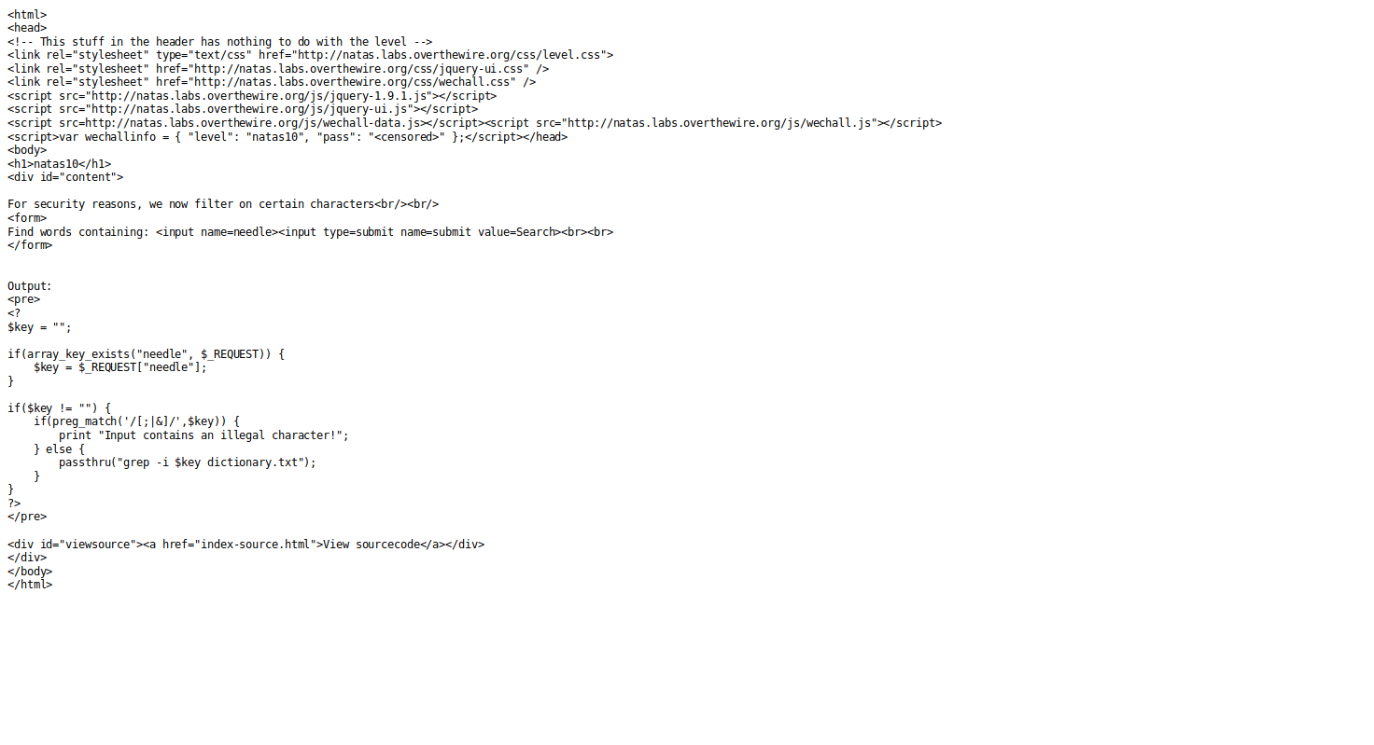

In source code we found that when we enter a keyword, it is passed via a function called passthru(). It takes the value in $key and it filters the input of the characters (/;|&) as shown in the given snapshot. We will use **. /etc/natas_webpass/natas11 #** in place of key to get the password. 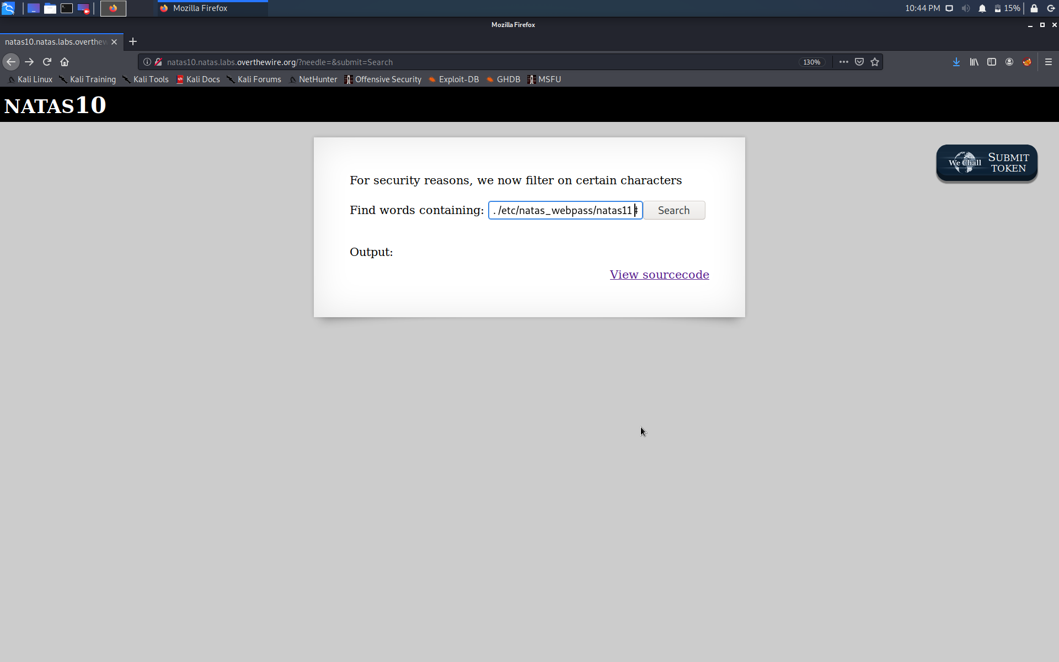

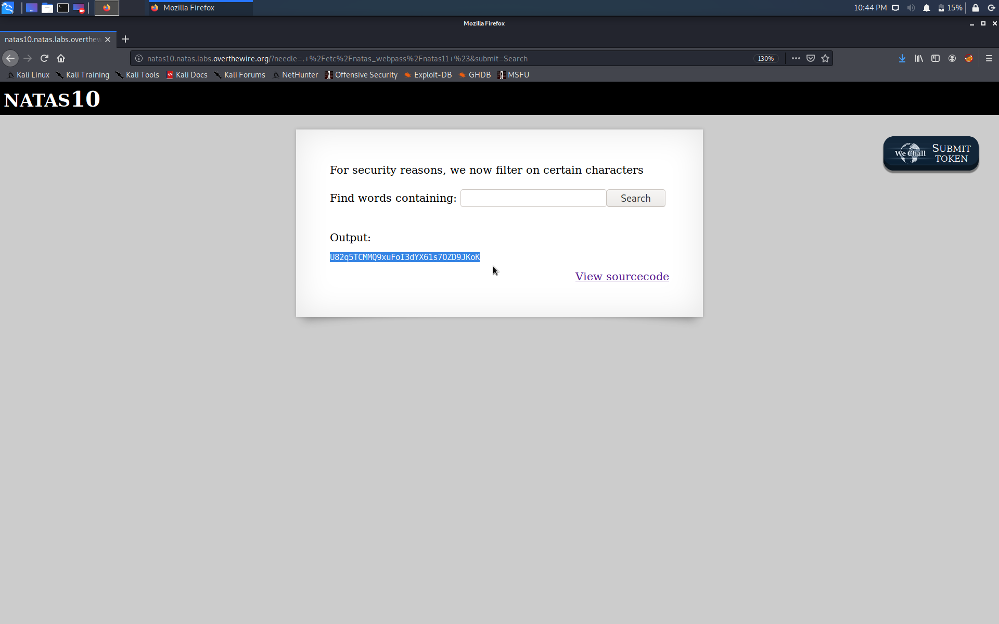

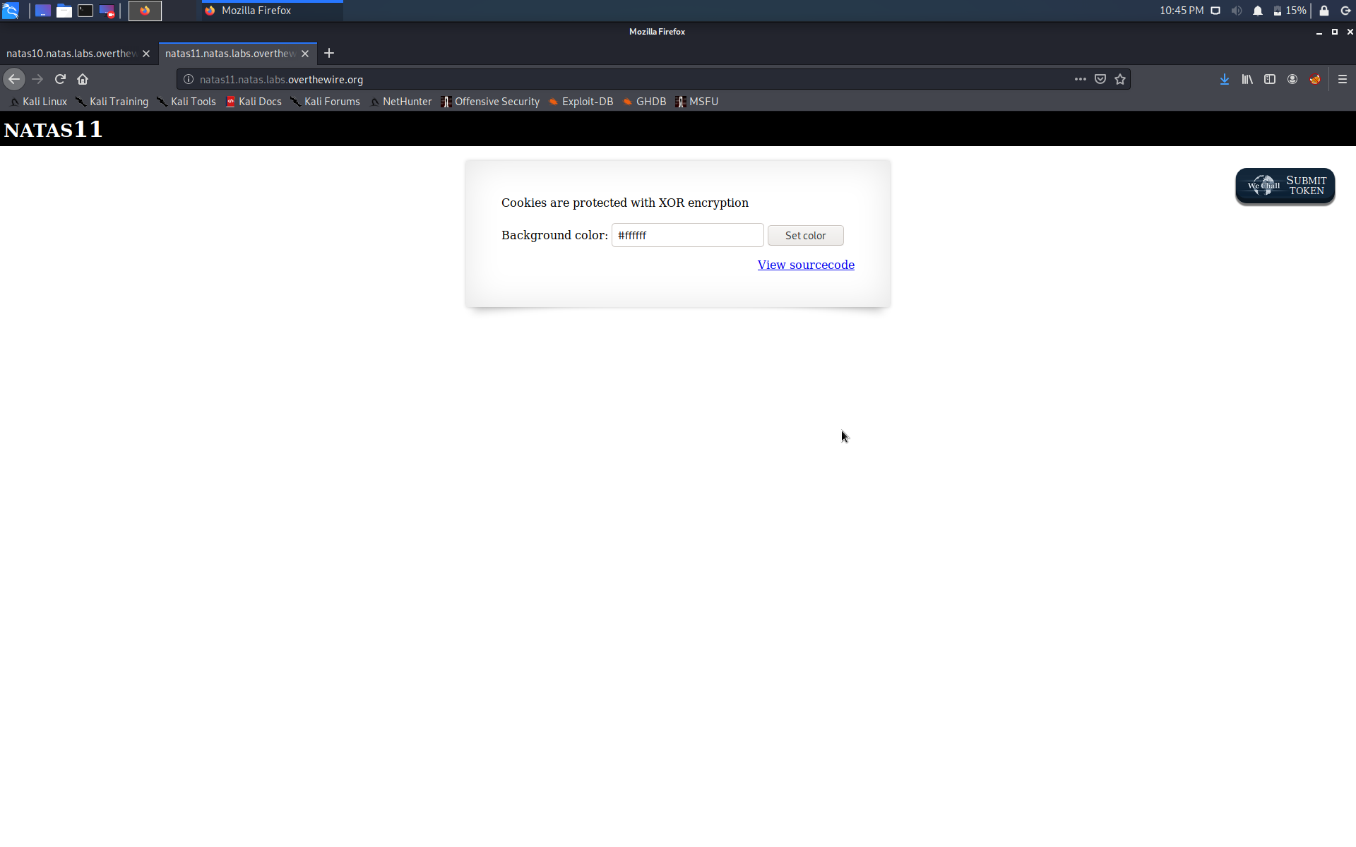

Successfully passed level 11.… 